

THE DEPOSITION HEARD ‘ROUND THE WORLD:

The Crisis Facing Paula Deen’s Celebrity Brand

Paula Deen, the renowned Southern chef, landed in boiling water after admitting to using the N word and tolerating racist jokes. The confession was made during Deen’s May 17, 2012, deposition in the case *Jackson v Paula Deen, et al.,* a racial discrimination case filed by one of Deen’s prior employees. The deposition transcript was leaked to the media on June 19, 2012, and Deen’s character was strongly questioned. As Deen fumbled with apologetic responses, many of Deen’s partners chose to sever their business relationships. This case highlights the importance of effective reputation management and crisis communication for all celebrity-dependent brands.



2014 Case Study Competition

**THE DEPOSITION HEARD ‘ROUND THE WORLD:**

**The Crisis Facing Paula Deen’s Celebrity Brand**

TABLE OF CONTENTS 1

I. CASE STUDY 2

1. Main Ingredients (Case Overview) 2

2. Whip until Fluffy (History) 2

3. Simmer until Tender (Crisis) 3

3.1 Lawsuit 3

3.2 Deposition 4

3.3 Deen’s Responses 5

3.4 Partners’ Responses 8

3.5 Media’s Responses 9

4. Kneed Until Smooth (Moving Forward) 12

4.1 Legal Outcome 12

4.2 Deen’s Comeback 13

4.3 Historical Comparison 13

II. APPENDICES 15

1. Selections from Paula Deen’s Deposition Transcript 15

2. Paula Deen’s *Today* Show Interview Transcript 25

III. REFERENCES 30

I. CASE STUDY

1. MAIN INGREDIENTS (Case Overview)

“Have you ever used the N word yourself?” The answer to this question sent Paula Deen Enterprises, LLC into a swift downward spiral. Paula Deen, the renowned Southern chef, answered, “Yes, of course.” Those words, stated under oath and transcribed, would be trumpeted for all to hear.

On May 17, 2012, an attorney voiced this poignant question during Deen’s deposition in a racial discrimination lawsuit filed against Paula Deen, et al. On June 19, 2012, the deposition transcript was leaked to social media, and many were appalled by Deen’s declaration. As Deen fumbled to respond to the media, many of Deen’s partners chose to sever their business relationships. Nine days after the transcript was publicized, Deen lost thirteen prominent partnerships.

Even though the legal case was dismissed on August 12, 2013, Paula Deen Enterprises, LLC’s reputation and Paula Deen’s personal brand were flattened. Deen is currently attempting to rebuild her brand with the guidance of public relation specialists. The following analysis of Paula Deen’s brand reputation crisis demonstrates the importance of effective corporate communication in business management.

2. WHIP UNTIL FLUFFY (History)

Paula Deen’s cooking career had a humble beginning. After her divorce in 1989, Deen and her two sons moved to Savannah, Georgia. With a few hundred dollars to her name, Deen decided to start a home-based catering company, The Bag Lady. Deen shared her Southern cooking in her “lunch-and-love-in-a-bag.” She soon moved from her kitchen to a small restaurant at a Best Western Motel in Savannah. In 1994 she opened her own restaurant, The Lady and Sons. After developing a personal brand reputation through The Lady and Sons restaurant, Deen published her first cookbook, *The Lady and Sons Savannah Country Cookbook*, in 1998. The publishing of this cookbook segued into her first television appearance on QVC. Deen’s warm personality was well received, and in 2002 the Food Network hosted Deen’s first cooking show, “Paula’s Home Cooking.” In 2006 the Food Network added “Paula’s Party” which included Deen’s sons, who are also chefs. Also in 2006, Deen incorporated as Paula Deen Enterprises, LLC. Deen authored many cookbooks and a bimonthly magazine, *Cooking with Paula Deen*. In recent years Deen expanded her business to include a second restaurant, Uncle Bubba’s Seafood and Oyster House, as well as multiple partnerships and licensees.1 In 2012, Forbes ranked Deen the fourth highest-earning chef in America with an annual income of $17 million.2

Deen’s rich Southern cooking received strong criticism in January of 2012 when she simultaneously announced that she had Type 2 diabetes and signed an endorsement deal with Novo Nordisk, a pharmaceutical company that produces Victoza, a diabetes medication. Well known is Deen’s use of large quantities of butter, cream cheese, and mayonnaise in her recipes; and social media responded with statements such as, “No wonder she has diabetes.” Deen also received criticism for keeping her Type 2 diabetes diagnosis a secret for three years, only to reveal it to benefit from an endorsement deal.3

3. SIMMER UNTIL TENDER (Crisis)

**3.1 Lawsuit**

In February 2005, Lisa T. Jackson began working as a hostess at Uncle Bubba’s Seafood and Oyster House, a restaurant co-owned by Paula Deen and her brother, Bubba Hiers. Within six months, Jackson was promoted to general manager. Jackson also performed catering work for Paula Deen Enterprises, LLC. In 2010, after five years of service, Jackson resigned.

On March 5, 2012, Lisa Jackson filed a complaint in the Superior Court of Chatham County, Georgia against Paula Deen; Paula Deen Enterprises, LLC; The Lady & Sons, LLC; The Lady Enterprises, Inc.; Earl W. “Bubba” Hiers; and Uncle Bubba’s Seafood and Oyster House, Inc. for alleged racial discrimination, sexual harassment, and a hostile work environment. The complaint gives examples of racial discrimination by both Paula Deen and Bubba Hiers toward Uncle Bubba’s Seafood and Oyster House employees. The complaints regarding sexual harassment and a hostile work environment are focused on Bubba Hiers, but it is stated that Deen was witness to the harassment and hostility. Jackson’s pretrial settlement demand was $1.2 million, but Paula Deen et al. was not willing to settle.4

Key quotations from the complaint:

“Bubba Hiers referred to her (Jackson) as ‘my little Jew girl.’”

“Paula Deen placed Ms. Jackson in charge of food and serving arrangements for the wedding of her brother Bubba Hiers in February 2007. When Ms. Jackson asked Ms. Deen what look the wedding should have, Ms. Deen replied, ‘I want a true southern plantation-style wedding.’ Asked by Ms. Jackson what type of uniforms she preferred servers to wear, Paula Deen stated, ‘Well what I would really like is a bunch of little n*****s to wear long-sleeve white shirts, black shorts and black bow ties, you know in the Shirley Temple days, they used to tap dance around.’ Paula Deen laughed and said, ‘Now that would be a true southern wedding, wouldn’t it? But we can’t do that because the media would be on me about that.’”4

The next day, March 6, 2012, Deen’s council, the Oliver Maner law firm, filed a gag order request based on the claimant’s intention to cause economic and personal ruin to Deen and influence the jury pool. The judge rejected the request because the potential damage did not outweigh the principles of freedom of speech and press. Oliver Maner responded with the following statement:

“Ms. Jackson did work for Uncle Bubba’s Seafood and Oyster House, and she did some work for Paula Deen Enterprises, LLC. She now claims that she was mistreated during her employment. We investigated those claims and attempted unsuccessfully to address those claims with her. She has made baseless, inflammatory allegations, threatening to go to the press and ruin Paula Deen’s reputation and the reputation of her businesses unless we paid her a large sum of money. We refused to bow to that kind of pressure and refused to pay money to address false claims. Ms. Jackson’s complaint makes false allegations against Paula Deen, and they will be proven false in court. We have filed our defensive pleadings with the court denying Ms. Jackson’s claims, and those pleadings are a matter of public record. We will hold Ms. Jackson and her lawyer accountable for these false allegations. We look forward to our day in court and have nothing further to say.”5

Because of the nature of the allegations, the case was moved to federal court in May of 2012. The federal court sealed the filings.6 In July 2013, Deen replaced her previous council, Oliver Maner, with Morgan Lewis & Bockius, an international law firm that specializes in employment claims. The law firm Weiner, Shearouse, Weitz, Greenberg & Shawe joined Morgan Lewis & Bockius as local counsel.7

**3.2 Deposition**

On May 17, 2012, Paula Deen was deposed by Lisa Jackson’s attorney. The deposition was transcribed and videographed.8 (Because of the length of the testimony, only pertinent pages of the transcript are included in Appendix 1.)

During the deposition, Deen was asked a series of questions relating to her brother Bubba Hiers’ personal life and professional conduct. When asked about her personal life, Deen admitted to telling off-colored jokes:

“We have all told off-colored jokes.”

When asked if she had ever used the N word, Deen responded,

“Yes, of course.”

Deen went on to explain that she used the N word when she was telling her husband about the black man who burst into the bank and put a gun to her head. She also said she was sure she had used the N word since then possibly in repeating something that was said to her.

Deen was asked to give an example of a nice or non-mean way to use the N word. She said:

“Depends on how it’s used in a joke. That’s -- kind of hard. Most -- most jokes target -- I don’t know. I didn’t make up the jokes, I don’t know. I can’t -- I don’t know. They usually target, though, a group. Gays or straights, black, redneck, you know, I just don’t know -- I just don’t know what to say. I can’t, myself, determine what offends another person.”

When asked about her conversation regarding the planning of Bubba Heirs’ wedding, Deen responded:

“I remember telling them about a restaurant that my husband and I had recently visited. And I’m wanting to think it was in Tennessee or North Carolina or somewhere, and it was so impressive. The whole entire wait staff was middle-aged black men, and they had on beautiful white jackets with a black bow tie. I mean, it was really impressive. And I remember saying I would love to have servers like that, I said, but I would be afraid that somebody would misinterpret.”

“Yes, I did say I would love for Bubba to experience a very southern style wedding, and we did that. We did that.”

The deposition centered around the management, employees, and specific events at Uncle Bubba’s Seafood and Oyster House. However, the deposition uncovered indignities beyond the scope of the lawsuit. On June 19, 2012, the transcript was leaked to the media, and Deen’s admissions regarding her racial comments were trumpeted across social media.9

**3.3 Deen’s Responses**

To publicly address her admissions, Deen was invited to interview with Matt Lauer from the *Today* show. The interview was scheduled for June 21, 2012, two days after her deposition transcript was leaked to the media. But the morning of the interview, Deen canceled due to exhaustion.10 The *Today* show stated on air that although Deen traveled to New York for the interview, that morning she cancelled because she was too exhausted. In response to the *Today* show’s announcement, Deen tweeted that she would release a video statment.11

tweet 1.tiff

The first video statement was heavily edited and choppy. Deen appeared emotional and drained. Within an hour of its posting, the video was removed from YouTube. However, it was captured in personal blogs.12

“I want to apologize to everybody, uh-- for the wrong that I’ve done. Uh-- I want to learn and grow from this. Inappropriate, hurtful language is totally, totally unacceptable. I’ve made plenty of mistakes along the way. But I beg you-- my children, my team, my fans, my partners, I beg for your forgiveness. Please forgive me for the mistakes that I’ve made.”

The second video statement, posted shortly after Deen’s first apology video was taken off YouTube, was slightly more professional.13

“Hello Y’all. I’m Paula Deen. I was invited this morning to speak with Matt Lauer about a subject that has been very hurtful for a lot of people. And Matt, I have to say I was physically not able this morning. Uh-- the pain has been tremendous that I have caused to myself and to others. And so I’m taking this opportunity, now that I’ve pulled myself together and am able to speak, to offer an apology to those that I have hurt. I want people to understand that um-- my family and I are not the kind of people that the press is wanting to say we are. Uh-- I have spent the best of 24 years to help myself and others. Your color of your skin, your religion, your sexual preference does not matter to me. But it what in the heart-- what’s in the heart. And my family and I try to live by that. And I am here to say I am so sorry. I was wrong. Yes, I’ve worked hard, and I’ve make mistakes but that is no excuse. And I offer my sincere apology to those that I have hurt, and I hope that you forgive me because this comes from the deepest part of my heart. And I will continue to work and continue to do good things for good people. Thank you fo, for listening.”

Later the same day, Deen issued a third apology statement specifically to Matt Lauer.14

“I’m Paula Deen, and I’m here to issue an apology to Matt Lauer. I was invited to do an interview with him this morning. And Matt, I am so sorry. I was physically in no shape to come in and talk with you. The last 48 hours have been very, very hard. And you know I am a strong woman. But today, I wasn’t. This morning, I was not. And so I do apologize.”

Matt Lauer invited Deen back to the *Today* show for her interview. The second interview was scheduled for June 26, 2013, seven days after her transcript was leaked. Deen was thankful for the second opportunity to appear on the *Today* show.14,15

FB1.tiff

Tweet June 25.tiff

Lauer began the interview (Appendix 2) by questioning Deen about canceling their first interview. Deen stated that she was overwhelmed and in a state of shock because some very hurtful lies were said about her. Lauer then questioned Deen, in an attempt to focus on the effects the racial admission had on her business, about the loss of her business partners the Food Network and Smithfield Foods. Deen sidestepped the question and made an emotional plea by stating she believes every one of God’s creatures was created equal, and that’s the way she lives her life. Lauer returned the conversation to her business woes by directly asking her if she was interviewing to stop the financial bleeding. Once again, Deen gave a personal, emotional response stating that the people who worked with her know her true personality. Deen also stated that she would not have fired herself, and she was thankful for the partners that decided to stand by her, like QVC.

Lauer directly asked Deen if she was racist. Deen replied that she was not a racist and supported her statement by quoting her father’s resentment of unkindness to others. Deen told Lauer that she had only used the N word once, during the bank robbery. This flatly contradicted her deposition. Lauer asked her about the part of her deposition regarding racist jokes. Deen responded that she did not know if the N word was offensive. She stated that she was distressed by her younger staff’s use of the word in the kitchen.

Once again connecting her situation to a personal example, Deen said that she was glad she told the truth, and she raised her children to tell the truth. She gave an example of her grandson Jack telling her, “Ginnie, I don’t tell lies.” As the interview concluded, Deen stated that she was heartbroken and became extremely emotional when she shared her appreciation for the support of her friends. In her last statements, Deen challenged anyone who has not said something they regret, to throw a stone at her head so hard it kills her.

“And I tell you what, if there’s anyone out there that has never said somethin’ they wish they could take back, if you’re out there, please pick up that stone and throw it so hard at my head that it kills me. Please. I want to meet you. I want to meet you. I is what I is, and I’m not changin’.”16

In addition to Rose Group, the public relations firm that manages Paula Deen Enterprises, LLC,17 Deen hired a crisis management firm and aligned with a civil rights leader. After realizing her YouTube apology videos were ineffective and most likely detrimental, Deen hired the crisis management firm, Smith & Co.18 Deen reached out to Rev. Jesse Jackson, a prominent African-American civil rights leader, to help her make amends. Jackson stated that because Deen acknowledged her mistake and was willing to make changes, she should be reclaimed.19

On July 4, 2012, Deen parted with her agent Barry Weiner. Weiner had been Deen’s agent for over ten years. Deen did not state a reason for severing the relationship. She thanked Weiner for his effort and dedication over the years.20

**3.4 Partners’ Responses**

Paula Deen Enterprises, LLC benefitted from many prominent partnerships and licensees. Although they certainly took note of Deen’s admission of using racial epithets, her partners gave her the opportunity to make a statement before they took action. Immediately following her YouTube apology videos, the Food Network announced they would not renew Deen’s contract when it expired at the end of June 2012. The Food Network hosted Deen’s shows, “Paula’s Best Dishes” and “Paula’s Home Cooking.”21

Three days later, Smithfield Foods severed their relationship with Deen, stating, “Smithfield condemns the use of offensive and discriminatory language and behavior of any kind. Smithfield is determined to be an ethical food industry leader, and it is important that our values and those of our spokespeople are properly aligned.”22 Random House even canceled the publication of Deen’s newest cookbook, despite the fact that preorders placed the cookbook as the number one seller on Amazon.23 Within one week, ten additional partners followed suit in breaking their relationships with Deen. The following table summarizes Deen’s lost partnerships:

|  |  |  |
| --- | --- | --- |
| Partner | Product/Service | Severance Date |
| Food Network21 | Three regular programs | 6/21/12 |
| Smithfield Foods24 | Pork product line | 6/24/12 |
| Wal-Mart25 | Cookware | 6/24/12 |
| White-Ash Furnishings, Inc.26 | Furniture line spokesperson | 6/25/12 |
| Caesar Entertainment Corporation27 | 4 Deen themed restaurants | 6/26/12 |
| Target Corporation28 | Cookware | 6/27/12 |
| QVC29 | Cookbooks and bakeware | 6/27/12 |
| Home Depot30 | Cookware | 6/27/12 |
| Novo Nordisk30 | Brand spokesperson | 6/27/12 |
| Random House23 | Cookbook publisher | 6/28/12 |
| Walgreens31 | Cookware | 6/28/12 |
| J.C. Penny31 | Cookware | 6/28/12 |
| Sears Holdings31 | Cookware | 6/28/12 |

Although Deen lost thirteen valuable partners, some partners chose to continue supporting Deen. Landies Candies’ president, Larry Szrama, issued a letter of support stating, “Your interview this morning reaffirms who you really are and what you believe. We count it a privilege to be your friend and business partner and look forward to sweet success in the future.”18 Tasty Blend Foods made the following statement, “We appreciate her commitment and how she stepped up and apologized to her viewers, fans, and the nation. We personally endorse Paula Deen and what she stands for. We are very saddened that she is being judged by her past; everyone has made a mistake sometime in their lives. We look forward to our continued partnership with her.”18

The following table summarizes Deen’s major ongoing partnerships:

|  |  |
| --- | --- |
| Partner | Product/Service |
| Landies Candies18 | Chocolates |
| Tasty Blend Foods18 | Dry mixes |
| High Point Furniture Company32 | Home collection |
| Hoffman Media33 | Magazines, cookbooks |
| Universal Furniture34 | Home line of furnishings |
| Spring Mountain Farms35 | Chicken meat |
| Alice Travel36 | Cruises |
| Metro Cooking Show37 | Appearances |

**3.5 Media’s Responses**

The media reacted strongly to Deen’s deposition transcript. Many of Deen’s fans remained loyal and showed their support through social media, restaurant visits, personal statements, and a creative protest. There was also a flood of derogatory comments that were shared on Twitter.

On June 22, 2012, the day after Deen posted her series of apology videos, John Schmitt, one of Deen’s supporters, began the Facebook page “We support Paula Deen.”The editors posted information regarding the decisions of Deen’s partners, encouraged supporters to make statements to support Deen, and promoted Deen’s products. By June 27, one week after the deposition transcript was leaked, the page had half a million likes. To date, the site has 611,000 likes.38 Deen’s fans also peppered her personal Facebook with likes, shares, and comments.15

We support Deen.tiff

FB2.tiff

The Saturday after Deen’s deposition transcript was publicized, a line of Deen’s fans waited for her restaurant, The Lady and Sons, to open. Although some of the supporters were offended by Deen’s use of the N word, most attributed it to the Deen’s era and were willing to forgive. Fans also discussed boycotting the Food Network for discontinuing its contract with Deen.39

High profile individuals also supported Deen. Aaron McCargo, an African-American chef who won Season 4 of “Food Network Star,” used his personal Facebook page to show his support and encourage his fans to give Deen the benefit of the doubt.40

Chef Aaron.tiff

Deen directly appealed to Rev. Jesse Jackson and broadly to the African-American church. Rev. Jonathan Walton, a professor of Christian morals at Harvard, explained that forgiveness was central to the civil rights movement, and forgiveness is grounded upon the basis that one cannot be held accountable for how he is treated by others, but God holds him accountable for how he treats others. Therefore forgiveness and reconciliation are central to the African-American church. Rev. Thurmond Neil Tillman, pastor of the First African Baptist Church in Savannah, shares a hometown with Deen and knows her well. Rev. Tillman has one question regarding the situation: have lessons been learned? When African-Americans are saying, “I wish I could work for Paula Deen,” then Rev. Tillman says the lesson was learned.41 The African-American church is ready and willing to forgive Deen, but they expect observable changes in the way her restaurants are managed.

John Schmitt, the author of the “We support Paula Deen” Facebook page, began the National Butter Wrappers for Paula Protest with the slogan, “A company without Paula is like a wrapper without butter. And, we want her back!” Protest participants are directed to mail a clean, empty butter wrapper and a letter to a corporation that dropped Paula Deen.42

Although Deen found a substantial crowd of forgiving fans, a multitude of critics assaulted Deen. Twitter #PaulasBestDishes was first used in 2010 to discuss Paula’s cooking shows. Immediately after Deen’s deposition transcript was publicized, the hash tag was hijacked and used to criticize Deen. People created racially charged titles for food dishes to attribute to Deen.43

Separate.tiff

freedom.tiffColored Greens.tiff

4. KNEED UNTIL SMOOTH (Moving Forward)

**4.1 Legal Outcome**

On August 12, 2013, almost a year and a half after the initial complaint was filed, Judge William Moore, Jr. dismissed the racial discrimination and hostile work environment complaints against Paula Deen et al. The judge stated:

“At best, Plaintiff [Lisa Jackson] is an accidental victim of the alleged racial discrimination. There are no allegations that Defendant Hiers’s racially offensive comments were either directed toward Plaintiff or made with the intent to harass her.”

“As Plaintiff neither suffered any adverse employment decision nor had any of the terms or conditions of her employment altered, these cases provide little support for her argument. While Plaintiff may have faced significant challenges in managing a workplace allegedly permeated with racial discrimination, her difficulties do not fall within the zone of interests sought to be protected by Title VII and cannot support a claim for racial discrimination under that statute.”44

The case was dismissed “with prejudice,” which means that the same lawsuit cannot be filed again. The court did not award fees or damages to either Jackson or Deen, et al.

**4.2 Deen’s Comeback**

After the crisis, Deen began her comeback with the help of a variety of partners and through extensive self-promotion. However, Deen’s annual income in 2013 was reportedly reduced to $3 million, approximately $14 million less than her income in 2012.45

On September 14, 2013, in Huston, Texas, Deen made her first public appearance since her deposition transcript was leaked. Deen’s appearance was a cooking demonstration hosted by Metro Cooking and Entertaining Show, an annual two-day event held in Washington DC, Houston, and Dallas. Before she could begin her demonstration, Deen’s fans gave her a standing ovation. Deen was moved to tears and expressed her appreciation for all the love and support shown to her during her difficult time.46

Stitches ‘n Dishes, a website that promotes food vendors, featured Paula Deen’s products to support Deen’s foundation, “The Bag Lady Foundation.” The foundation works with communities to support women and families facing economic challenges. With the help of Stitches ‘n Dishes, Deen found a new avenue to sell her cookware while simultaneously promoting her foundation.47

Paula Deen is hosting interactive cooking classes through the Paula Deen’s Cooking School in Savannah, Georgia. The classes are four hours and include an interactive lesson on creating a specific three-course meal. Registration is $250 per individual. Deen’s October 25, 2013, class sold out. Deen plans to host a holiday cooking school on December 13. The holiday cooking school is sold out and the waiting list is closed.48

In addition to the traditional business interests of chefs, Deen hosts celebrity cruises. The cruise destinations include the Eastern and Western Caribbean. They promote a time of relaxation and fun with Paula Deen. Alice Travel organizes the Paula Deen & Family Party-at-Sea cruises. There are two cruises scheduled for January and July 2014, and they are expected to sell out. Many of Deen’s fans are purchasing the cruises to express their support.49

**4.3 Historical Comparison**

Celebrities’ words often land them squarely in the media’s critical eye. Some celebrities are able to rebuild their careers, and others are unable to rebuild. The comparison of Deen’s crisis against the crises of Martha Stewart, Don Imus, and Michael Richards lends speculative outcomes for Deen.

In 2003, Martha Stewart, a famous chef, was found guilty of making false statements to federal investigators, conspiracy, and obstruction of justice regarding insider trading of ImClone Systems stock. In the eyes of the public, Stewart was not thought to have criminal intentions. Being convicted of insider trading was surprising, and the public was willing to accept her apology. Stewart made a prompt comeback with cooking shows filmed from her home, Home Depot’s Martha Stewart Living line, and Martha Stewart Home Office line at Staples.50

At a November 2006 performance, Michael Richards, known for his portrayal of Kramer on Seinfeld, shouted racially charged comments to the audience. Richards made an ineffective public apology in which he personified his Kramer character. Failing to express personal remorse, many considered Richard’s apology insincere, and he was unable to rebuild his career.51

Don Imus, a radio host, was suspended by CBS in April 2007 for making racist comments about the Rutgers University women’s basketball team. Imus made an official apology for his racial coments. The media accepted Imus’ apology as genuine in part because the Rutgers team officially accepted Imus’ apology. Four months after his suspension, Imus signed a contract with Cumulus Media.52

The linking factor in these examples is the media’s perception of the genuine character of the apology. Because the media believed Martha Stewart and Don Imus were genuinely remorseful for their actions, the stars were able to rebuild their careers. However, the media did not accept Michael Richards’ apology to an extent that would allow him to rebuild his acting career.

Earlier in this case study, the analysis of the media’s responses showed two distinct perceptions. One perspective considered Deen’s apology genuine, the other did not. The prevailing perception will dictate the extent to which Deen’s career can be rebuilt.

Despite the significant business problems caused by the crisis, Deen is attempting to rebuild her career. With the loss of national partners, Deen is currently limited to smaller, typically local, partners. Although Deen won in the court of law, the court of public opinion is still in session. Public opinion dictates partnerships and purchases, and unless the tide of public opinion shifts, Deen’s career will be stinted.

II. Appendices

**1. Selections from Paula Deen’s Deposition Transcript8**

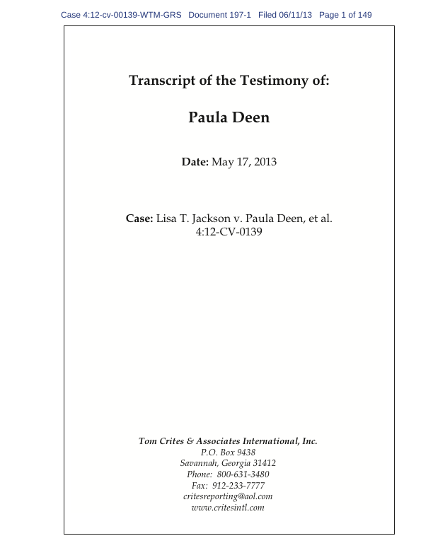

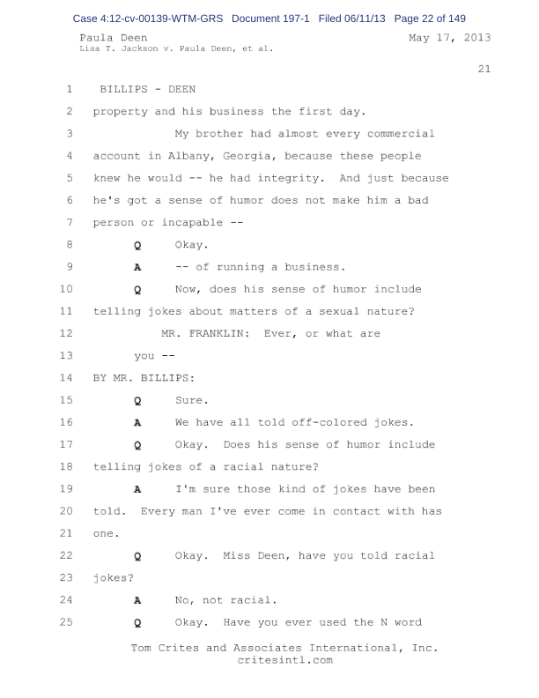

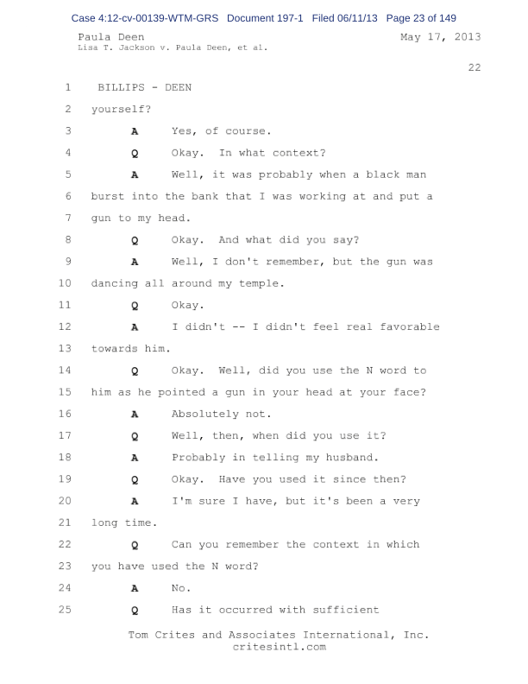

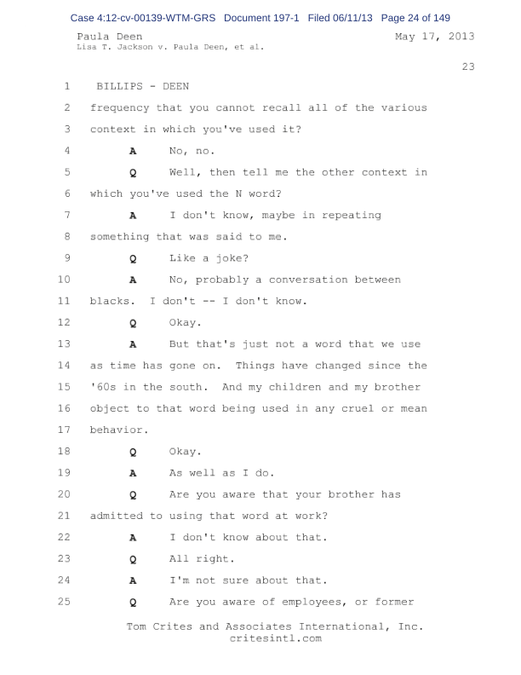

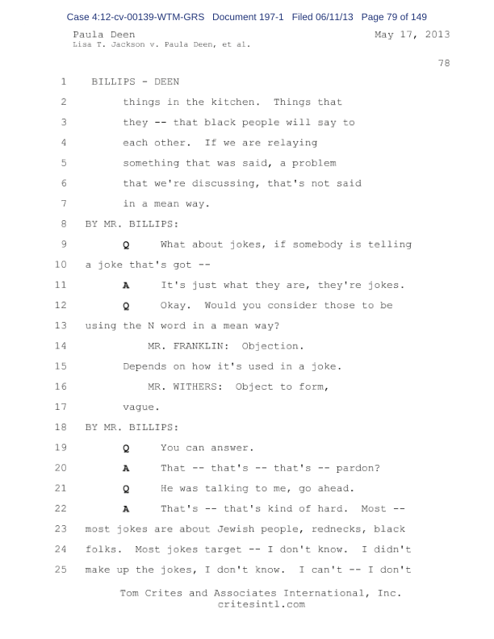

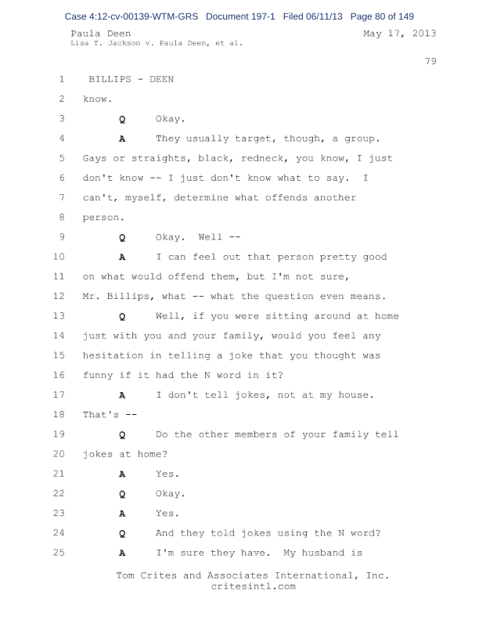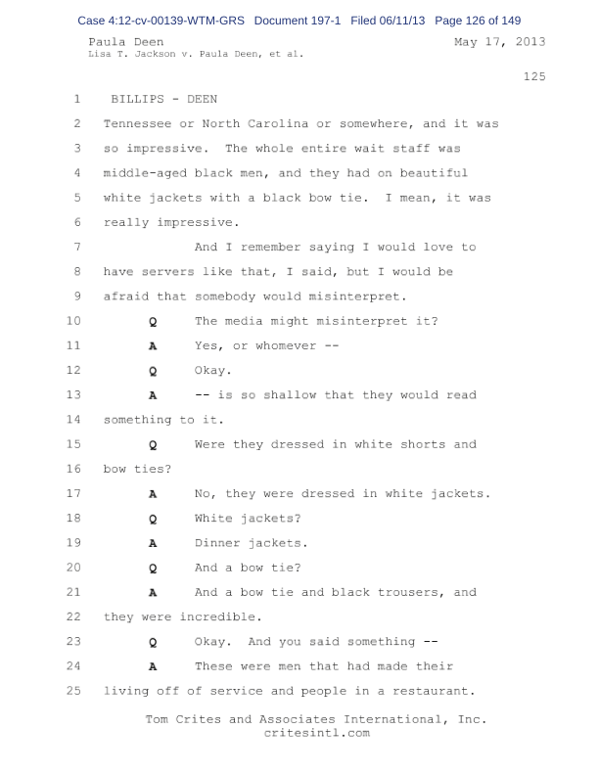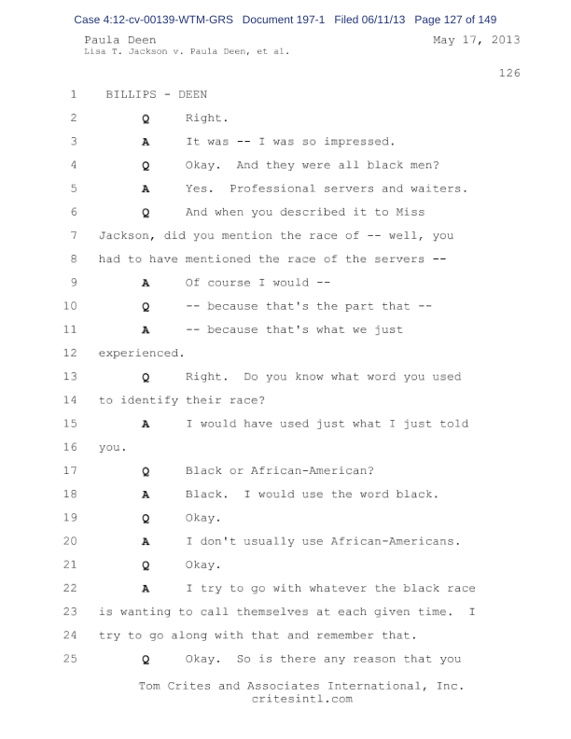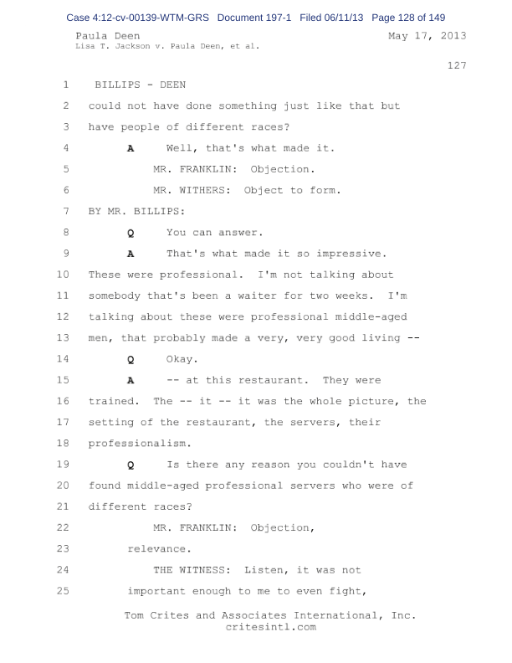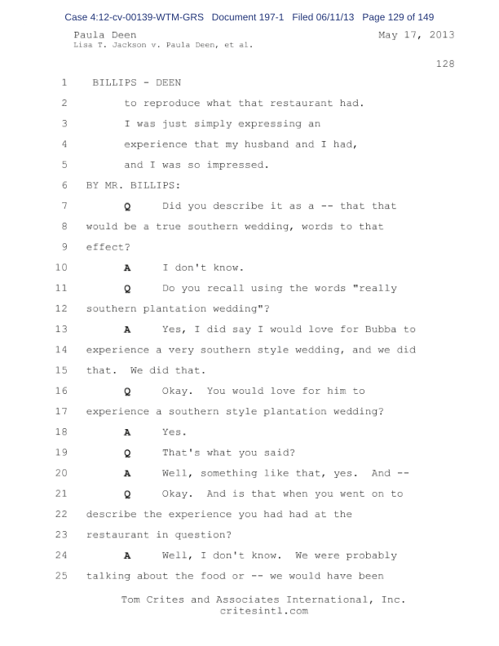

**2. Paula Deen’s “Today” Interview Transcript16**

MATT LAUER: You were gonna be here Friday.  You basically said you were exhausted.  You told me you were distraught.  How are you doin’ today?

PAULA DEEN: I was– I– it’s hard for me to even find the word, Matt, that I was feelin’.  I was just overwhelmed.  I– I was in a state of shock.

MATT LAUER: Still?

PAULA DEEN: Somewhat, yes.  Because– there has been some very, very hurtful lies said about me.

MATT LAUER: I wanna– I wanna get to specifics in a second, Paula.  The difference between Friday and now is really on the business side of things.

PAULA DEEN: Yes. Yes.

MATT LAUER: But, now–let me just– Food Network says no more.  Smithfield Foods said they’re severing ties with you.  QVC, a big partner of yours, is weighing their options.  Do you think you’ve been treated fairly by your business partners?

PAULA DEEN: They– let me say this.  Before we even get into that.  The main reason I am here today, Matt, is it’s important to me that I tell you and everyone out there how– what I believe and how I live my life.  I believe that every creature on this earth, every one of God’s creatures was created equal.  No matter who you choose to go to bed at night with, no matter what church you go to pray, I believe that everyone should be treated equal.  And that’s the way I was raised and that’s the way I live my life.

MATT LAUER: One of the headlines –I read, Paula–said that there– you know– said millions of dollars at stake for Paula Deen in Today Show interview.  So, are you here to express what you just said?  Or are you here to stop the financial bleeding?

PAULA DEEN: I am here today because I want people to know who I am.  And people that have worked beside me, have walked beside me know what kinda person I am.  And I– I’m so distressed that people I’ve never heard of are all of a sudden experts on who I am.  And you know what distresses me the very most, Matt?  Their words are bein’ given weight.

MATT LAUER: Well, they’re having an impact, Paula–let’s stay on the business side for a second–do you think you’ve been treated fairly by the companies that have now distanced themselves from you?  You are a cook, but you’re also a businesswoman.  You’re the head of a brand.  You understand–the bottom line.  You understand image.  Given the same circumstances, would you have fired you?

PAULA DEEN: Would I have fired me, knowin’ me?  No.  I’m very lucky in this aspect, Matt.  I’m so fortunate that so many of my partners that know who I am have decided to stand by me.  QVC has not dropped me.

MATT LAUER: They say they’re weighing their options.

PAULA DEEN: Well, there’s– there’s only two that has dropped me.  And I am so very thankful for the partners that I have that believe in me.

MATT LAUER: Right now as we sit here, it seems to me an informal jury of your peers –and your fans and your critics and your business associates are– are weighing the question, “Is Paula Deen a racist?”  So, I’ll ask it to you bluntly.  Are you a racist?

PAULA DEEN: No.  No, I’m not.

MATT LAUER: By birth, by choice, by osmosis, you don’t feel you–have racist tendencies?

PAULA DEEN: No.  As a child, I was raised in a home that my father tolerated bad grades.  He would tolerate m– maybe me breakin’ a curfew.  But he told me, he said, “Girl, if I ever find out that you have behaved in a way where you think you’re better than others, or have been unkind, your butt is gonna be mine.”

MATT LAUER: All right.  But you raised your right hand--and you swore under oath–that you have used a word that is the most offensive word you can use to describe an African American.  And you’ve talked about this wedding, this wedding you wanted to plan, that plantation-style wedding, whether you used the n-word or not.  So, how does someone–use the n-word, whether in anger or in a joke or in private, the most offensive word to African Americans and not be considered a racist?

PAULA DEEN: Yes.  The day I used that word, it was a world ago.  It was 30 years ago.  I had had a gun put other my head, a shakin’ gun, because the man that had the gun to my head, unbeknowing to me, was my customer at the main office.

MATT LAUER: But didn’t you also–admit, though, that you used the word on other occasions?

PAULA DEEN: No.  No.  No.

MATT LAUER: So, you have– other than that one time–in the bank, a robbery event, you’re tellin’ me you have never used–the n-word?

PAULA DEEN: I have–never.  I never.  They asked me in all of my 66 years on earth, had I ever used it.  That man was so frightened that day he put the gun to my head because he was a customer at the main office.  He was later caught.  And I had gone out on a limb for him and gotten him alone.  And he was frightened that I was gonna–

MATT LAUER: So, reports–that you were asked in that deposition whether you had used the n-word on other occasions and said, “Probably,” or, “Of course” are in– are inaccurate?

PAULA DEEN: No.  I answered the question truthfully.

MATT LAUER: So, you have never used the n-word, other than that one–occasion

PAULA DEEN: No.  It’s–just not– it’s just not a part of– it’s just not a part of who we are.

MATT LAUER: Lemme ask you about this part of the deposition.  We were asked whether– you were asked whether using the n-word in telling a joke was hurtful.  And you said, quote, “I don’t know.  Most jokes are about Jewish people, rednecks, black folks.  I didn’t make up the jokes.  They usually target, though, a group.  I can’t, myself, determine what offends another person.”  That last sentence gets me.  “I can’t–”

PAULA DEEN: And I can’t.

MATT LAUER: “–myself determine what offends another person.”  Do you have any doubt in your mind that African Americans are offended by the n-word?

PAULA DEEN: I don’t know, Matt.  I have asked myself that so many times.  Because– it’s very distressing for me to go into my kitchen and I hear what these young people are callin’ each other.  It’s very, very distressing.

MATT LAUER: And you’ve never joined in on that language?

PAULA DEEN: No.  Absolutely not.  It’s very distressing.  It’s very distressing for me because I think that for this problem to be worked on, that these young people are gonna have to take control and start showin’ respect for each other and not throwin’ that word at each other.  That– it is– it makes my skin crawl.

MATT LAUER: I wanna read you something that Columbia Professor John McWhorter s– wrote for Time Magazine’s website.  He is, by the way, African American.  He write, “People of Deen’s generation can neither change the past nor completely escape their roots in it any more than the rest of us.  They can apologize and mean it, as Deen seems to.

“They also deserve credit for owning up to past sins, as Deen did candidly, when she could’ve easily, shall we say, whitewashed the matter.”  Do you ever wish, Paula, that when you raised your right hand and swore to tell the truth in that deposition that you’d fudged the truth?  You wouldn’t have been the first person who ever lied under oath.  Given the fallout that you’ve seen over the last week, do you ever wish you’d fudged the truth?

PAULA DEEN: No.  Because– there’s a couple of kinds of people that I don’t like that I am prejudiced against, Matt, and that’s thieves and liars.  And I’ll tell you a conversation that I had with my seven-year-old grandson the other day.  He had spent the night with me and I allowed him to stay up later than his bedtime.

And I said, “Jack, honey, you got– get me in trouble with Mommy and Daddy when you told them that I had let you stay up late.”  And he was playin’ with my iPad.  And he put that iPad down, and he looked up at me, and he said, “Ginnie (PH), I don’t tell lies.”  That’s how I raised my children.  That’s how I was raised.  And that’s how my grandchildren are bein’ raised.

And I know– as well as I’m sittin’ here with you, I know how I treat people.  I know my love for people.  And I’m not gonna sit here and tell everything the I have done for– people of color.  I’m not gonna do it.  Somebody else can tell that.

MATT LAUER: There are a lotta people who’ve shown up at your restaurant in Savannah to support you–the lines have grown.  They’ve gone to Twitter.  They’ve shown–their support for you there.  Some have called for a boycott of the Food Network for the way–they have dealt with you.

PAULA DEEN: Yeah.  And I don’t–I don’t want that.

MATT LAUER: Is your salvation in that core group of fans– can you rely on your base and focus, to use a political term, on that base and survive this?

PAULA DEEN: I think that we can never underestimate the power of those voices.  Because these people who have met me and know me and love me, they’re as angry as the people are that are readin’ these stories that are lies.  These people readin’ the stories that don’t know me, they don’t know they’re not lies.

They have no idea.  So, they are angry.  And on that same coin, the people that know me, they are just as angry.  And– I have apologized.  I would never, never– and I can truthfully say in my life, I have never with any intention hurt anybody on purpose.  And I never would.

MATT LAUER: And there’s not another side of this personality that we see on TV, this– this warm–sugary, sweet, even sassy girl of the South?  There isn’t a side of you–that is intolerant and, perhaps, views others as– as not equal?

PAULA DEEN: No.  No.  You know, I– I– no.  What you see is what you get.  I’m not an actress.  I’m heart broken.  I’m thankful for my partner.

MATT LAUER: Heartbroken why?  Heartbroken for yourself or your–family?

PAULA DEEN: Heartbroken–I’ve had to hold friends in my arms while they’ve sobbed because they what’s bein’ said about me is not true.  And I’m havin’ to comfort them and tell them it’s gonna be all right.  If God got us to it, he’ll get us through it.  I’ve had wonderful support from Reverend Jackson.

(SNIFF) I’ve had wonderful support.  And I tell you what, if there’s anyone out there that has never said somethin’ that they wish they could take back, (SNIFF) if you’re out there, please pick up that stone and throw it so hard at my head that it kills me.  Please.  I want to meet you.  I want to meet you.  I is what I is and I’m not changin’.  And I– there’s someone evil out there that saw what I had worked for and they wanted it.

MATT LAUER: Let’s end it on that.  Paula Deen, thanks for bein’ here this morning, I–appreciate it.

PAULA DEEN: Thank you for havin’ me–Matt.  It means a lot to me and it feels so strange to come to this wonderful, happy place where I’ve always come so happy (SNIFF) and to have these people believe these horrible, horrible lies when all you have to do is ask the people around me.

PAULA DEEN: Because I live my life the way I believe.  And like I said, if you’ve never committed a sin, please pick up that rock, pick up that boulder, and hit me as hard as you can.

MATT LAUER: We’ll end it there.  Paula Deen, thank you.  And we’re back right after this.

III. REFERENCES

1 Paula’s Story. Retrieved from <http://www.pauladeen.com/paula/>

2 Forbes. *The Top Earning Chefs*. Retrieved from <http://www.forbes.com/special-report/2012/highest-earning-chefs/paula-deen.html>

3 Moskin, J. (2012, January 1). Chef Has Diabetes, and Some Say ‘I Told You So.’ *The New York Times*. Retrieved from <http://www.nytimes.com/2012/01/18/dining/paula-deen-says-she-has-type-2-diabetes.html?pagewanted=all&_r=0>

4 Complaint. Jackson v. Paula Deen, et al. Retrieved from <http://www.courthousenews.com/2012/03/07/Bubbas.pdf>

5 Filip, I. (2012, March 23). Judge Nixes Paula Deen’s Gag Order Request. *Courthouse News Service*. Retrieved from <http://www.courthousenews.com/2012/03/23/44954.htm>

6 Caldwell, C. (2012, May 23). Paula Deen lawsuit now in federal court. *Atlanta Business Chronicle*. Retrieved from <http://www.bizjournals.com/atlanta/morning_call/2012/05/paula-deen-lawsuit-now-in-federal-court.html>

7 Filip, I. (2013, July 15). New Lawyers for Deen After N-Word Debacle. *Courhouse News Service*. Retrieved from <http://www.courthousenews.com/2013/07/15/59379.htm>

8 Transcript of the Testimony of: Paula Deen (2013, May 17). Retrieved from <http://www.courthousenews.com/2013/07/01/Paula%20Deen%20Deposition.pdf>

9 National Enquirer (2013, June 19). World Exclusive Cover Story: Paula Deen Racist Confessions. Retrieved from <http://www.nationalenquirer.com/celebrity/world-exclusive-cover-story-paula-deen-racist-confessions>

10 Today. (2013, June 21). Deen a no-show for TODAY interview. Retrieved from <http://www.today.com/video/today/52272603#46511834>

11 Paula Deen’s Twitter. Retrieved from <https://twitter.com/Paula_Deen>

12 Voorhees, J. Paula Deen’s (Super) Awkward Apology Videos Weren’t Enough to Save Her Job. Retrieved from <http://www.slate.com/blogs/the_slatest/2013/06/21/paula_dean_apology_celebrity_chef_begs_for_forgiveness_for_using_racial.html>

13 Rao, V. (2013, June 21). Food Network ‘will not renew Paula Deen’s contract.’ *Today Food*. Retrieved from <http://www.today.com/food/food-network-will-not-renew-paula-deens-contract-6C10408932>

14 YouTube. Paula Deen’s Third Apology Video. Retrieved from <http://www.youtube.com/watch?v=9L9LOfVlNxc>

15 Paula Deen’s Facebook. Retrieved from <https://www.facebook.com/PaulaDeen>

16 Rao, V. (2013, June 26). Paula Deen: I would not have fired me. *Today.* Retrieved from <http://www.today.com/food/paula-deen-i-would-not-have-fired-me-6C10454147>

17 PR and Personal Appearances. Retireved from <http://www.pauladeen.com/contact>

18 Bruell, A. (2013, June 26). Some Brands Show Support After Paula Deen Hires Crisis PR Shop. *Adage*. Retrieved from <http://adage.com/article/media/paula-deen-hires-smith-inspiration-scandal/242849/>

19 Webber, T. (2013, June 26). Rev Jess Jackson: Paula Deen Can Be ‘Redeemed.’ *Huffington Post*. Retrieved from <http://www.huffingtonpost.com/2013/06/26/jesse-jackson-paula-deen_n_3506218.html>

20 Hawkins, L. (2013, July 4). Celebrity chef Paula Deen splits with her longtime agent. *Wall Street Journal*. Retrieved from <https://login.ezproxy1.lib.depaul.edu/login?url=http://search.proquest.com/docview/1386986596?accountid=10477>

21 Hagey, K. (2013, June 21). Food network won't renew Paula Deen's contract. *Wall Street Journal*. Retrieved from <https://login.ezproxy1.lib.depaul.edu/login?url=http://search.proquest.com/docview/1370245370?accountid=10477>

22 Severson, K. (2013, June 24). Paula Deen Loses Major Endorsement Deal. *The New York Times*. Retrieved from <http://www.nytimes.com/2013/06/25/us/paula-deen-loses-major-endorsement-deal.html?_r=0>

23 Deahl, R. (2013, June 28). Random House Drops Paula Deen. *Publishersweekly.com*. Retrieved from <http://www.publishersweekly.com/pw/by-topic/industry-news/publisher-news/article/58013-random-house-cancels-deen-book.html>

24 Rao, V. (2013, June 24). Paula Deen dropped by Smithfield Foods. *Today Food*. Retrieved from <http://www.today.com/food/paula-deen-dropped-smithfield-foods-6C10423983>

25 Moskin, J. (2013, June 26). Walmart to Stop Selling Deen’s Products. *The New York Times.* Retrieved from <http://www.nytimes.com/2013/06/27/dining/deen-takes-to-today-show-for-tearful-defense.html?_r=0>

26 Stewart, M. (2013, June 25). Paul Deen Continues to Lose Endorsement Deals. *Avid Cooking*. Retrieved from <http://www.avidcooking.com/tag/crisis>

27 Forbes, P. (2013, June 26). Caesars Terminates Relationship With Paula Deen, Shutters Four Restaurants. *Eater*. Retrieved from <http://eater.com/archives/2013/06/26/caesars-terminates-relationship-with-paula-deen.php>

28 NBC WAGT 26. (2013, June 27). Target latest company to cut ties with Paula Deen. Retrieved from <http://www.nbc26.tv/story/22703454/target-latest-company-to-cut-ties-with-paula-deen>

29 George, M. (2013, June 27). A Letter from QVC CEO Mike George and a Letter from Paula Deen. *QVC Blog*. Retrieved from <http://community.qvc.com/blogs/q+news/topic/387209/a-letter-from-qvc-ceo-mike-george-and-a-letter-from-paula-deen.aspx>

30 O’Connor, C. (2013, June 27). Paula Deen Dumped By Home Depot And Diabetes Drug Company Novo Nordisk As Target, Sears, QVC Mull Next Move. *Forbes*. Retrieved from <http://www.forbes.com/sites/clareoconnor/2013/06/27/paula-deen-dumped-by-home-depot-and-diabetes-drug-company-novo-nordisk-as-target-sears-qvc-mull-next-move/>

31 Rao, V. (2013, June 28). Paula Deen’s cookbook deal cancelled after 11 other companies drop her. *Today*. Retrieved from <http://www.today.com/food/paula-deens-cookbook-deal-cancelled-after-11-other-companies-drop-6C10452621>

32 WFMY News 2. (2013, July 25). High Point Furniture Company To Continue With Paula Deen. Retrieved from <http://www.digtriad.com/news/article/292611/57/High-Point-Furniture-Company-To-Continue-With-Paula-Deen>

33 Elliott, N. (2013, July 3). Hoffman Media to publish Paula Deen’s cookbook. *The Celebrity Café*. Retrieved from <http://thecelebritycafe.com/feature/2013/07/hoffman-media-publish-paula-deen-s-cookbook>

34 Universal Furniture Paula Deen Home Collection. Retrieved from <http://www.universalfurniture.com/ss_34H11fh.aspx?ri=4807932c-833f-42bd-9e70-6113d08a6bb4&id=ef30ebb1-f08d-4325-90cf-1ea7143141c6>

35 Springer Mountain Farms. Retrieved from <http://springermountainfarms.com/Merchant5/merchant.mvc>.

36 Alice Travel. Retrieved from <http://www.alicetravel.com/index.aspx>

37 Metro Cooking and Entertaining show. Retrieved from <http://www.metrocookingdc.com>

38 We support Paula Deen. Retrieved from <https://www.facebook.com/WeSupportPaulaDean>

39 Severson, K. (2013, June 22). At Georgia Restaurant, Patrons Jump to Defend a Chef From Her Critics. *The New York Times*. Retrieved from <http://www.nytimes.com/2013/06/23/us/in-the-south-many-are-willing-to-forgive-deens-racial-misstep.html>

40 Chef Aaron McCargo Jr’s Facebook. Retrieved from <https://www.facebook.com/ChefMcCargoJr/posts/10151428891496436>

41 Freedman, S. (2013, June 28). A Celebrity Chef Appeals to a Legacy of Black Forgiveness. *The New York Times*. Retrieved from <http://www.nytimes.com/2013/06/29/us/paula-deen-appeals-to-a-legacy-of-black-forgiveness.html>

42 Butter for Paula. Retrieved from <http://butterforpaula.org>

43 Twitter #PaulasBestDishes, Retrieved from <https://twitter.com/search?q=%23PaulasBestDishes&src=hash&f=realtime>

44 Order. Jackson v. Paula Deen, et al. Retrieved from <http://www.courthousenews.com/2013/08/13/paula.pdf>

45 Smith, Aaron. (2013, August 13). Winning suit won’t put Paula Deen back in the money. *CNN Money*. Retrieved from <http://money.cnn.com/2013/08/13/news/companies/paula-deen-wealth/>

46 MetroCooking. Retrieved from <http://www.metrocookingdallas.com/personalities/>

47 Stitches ‘n Dishes Paula Deen Products. Retrieved from <http://stitchesndishes.com/shop-snd-2/>

48 Paula Deen’s Cooking School. Retrieved from <http://www.pauladeen.com/index.php?%2Fcookingschool>

49 Brown, G. (2013, June 27). Paula Deen Cruises Sail Despite Stormy seas for Disgraced Celebrity Chef. Retrieved from <http://abcnews.go.com/Travel/paula-deen-cruises-sail-amidst-sea-controversy/story?id=19505683>

50 Marketing matha. (2012, August 25). *Wall Street Journal*. Retrieved from <https://login.ezproxy1.lib.depaul.edu/login?url=http://search.proquest.com/docview/1034913899?accountid=10477>

51 Sharpton: Comedian’s apology not enough. (2006, November 23). Retrieved from <http://www.cnn.com/2006/SHOWBIZ/TV/11/22/sharpton.richard/index.html>

52 Sanders, P. (2007, August 15). CBS, Imus Reach Contract Settlement; Deals Fuels Speculation that Fired Radio Host might make Comeback. *Wall Street Journal*. Retrieved from <https://login.ezproxy1.lib.depaul.edu/login?url=http://search.proquest.com/docview/399043479?accountid=10477>